Lung Cancer Prediction using Machine Leaning Techniques

|  |  |  |
| --- | --- | --- |
| Aadi Poddar School of Computer Engineering KIIT Deemed UniversityBhubaneswar, Odisha, INDIA aadipoddarmail@gmail.com | Anjisnu Saw School of Computer Engineering KIIT Deemed UniversityBhubaneswar, Odisha, INDIA aadipoddarmail@gmail.com | Jay Prakash Singh *Dept of Computer Science & Engineering Manipal University Jaipur* Jaipur, Rajasthan, India jayprakash.singh@jaipur.manipal.edu |
| Mahendra Kumar Gourisaria *School of Computer Engineering KIIT Deemed to be University* Bhubaneshwar, Odisha, India mkgourisaria2010@gmail.com | Sonal Jain *School of Economics and Commerce KIIT Deemed to be University* Bhubaneshwar, Odisha, India sonalhzbjain@gmail.com | Jay Prakash Singh *Dept of Computer Science & Engineering Manipal University Jaipur* Jaipur, Rajasthan, India jayprakash.singh@jaipur.manipal.edu |

Abstract – The most commonly diagnosed cancers in the world are Lung cancer. Beforehand prediction, detection and diagnosis of lung cancer has become essential. This paper draws light to the lung cancer predictions and detection using common life habits and attributes. Predictions are based on different parameters like gender and age of the person and their habits like smoking and alcohol consumption. The effectiveness of lung cancer prediction system helps the doctor and patients to know their lung cancer risk with minimal cost. The prediction helps people to take appropriate actions based on their lung cancer risk status. This paper involves various machine learning regression models like Lasso Regression, Linear Regression, Ridge Regression, Decision Tree and Random Forests. In this paper all the above models are compared, and it is found that Random Forest Regressor outperforms the best results in MSE, RMSE and R2 Score as compared to other models.

Keywords—Lung Cancer Detection, Machine Learning, Predictive Modeling, Health data analytics, Regression Analysis

# Introduction

Lung cancer contributes to one of the most reported global cancer deaths. As per the data 1.8 million new cases are reported every year. Lung cancer accounts for the highest mortality rate among both men and women. Smoking is the leading cause of lung cancer and cancer deaths; it leads to 85% of all cases [1]. Most people are diagnosed at an advanced stage of lung cancer which results in a low survival rate. Lung cancer accounted for 14% of all cancer diagnoses and 27% of all cancer deaths in the last few years [2]. In order to anticipate and identify lung cancer as early as possible, machine learning engineers and data scientists are attempting to forecast lung cancer for the general public. Predicting and determining cancer in an early stage is better and has a higher chance of cure and the patient has a higher rate of survival. The various aspects of Machine Learning and Data is cleaned and sorted before training the models removing unnecessary data attributes which do not contribute in the classification and prediction process.

The machine learning models used in this paper use attributes regarding basic information about the person like gender and age. It consists of other attributes like habits of the person like smoking and alcohol consumption. It takes more information about how the person feels in day-to-day life like Fatigue, feels exhausted, feels wheezing in which they make a high-pitched sound while breathing, person has Swallowing Difficulty, shortness of Breath, yellow fingers, Chest pain, and is under Peer Pressure. All these variables and attributes are combined to give the lung cancer result which is the target variable.

Lung cancer prediction using Machine Learning Regression models is getting popular day by day helping doctors catch the diseases earlier and save life. It is important and beneficial to estimate and predict the risk of cancer and the percentage of risk accurately to the patients and doctors for the sake of proper medication and treatment can be made accurately within a proper time frame.

Detection and diagnosing of lung cancer is a great challenge encountered by doctors and researchers now a days. Machine Learning models approaches recognize the main attributes of complex datasets of lung cancer. A CAD (Computer-Aided Diagnosis) emerged in the early 1980s to improve and enhance the survival rate and efficiency that helped doctors globally in interpreting medical images [3].

Lung cancer prediction using the basic human habits are necessary because existing clinical techniques such as X-Ray and other imaging procedures for detecting cancer require complex hardware. These techniques are expensive, and this raises the need for machine learning models that are comparatively cheaper and easy to access. Simple and easy to use machine learning models are essential for the detection of cancer in remote locations and places where medical facilities have not been established yet. It is essential for a vast variety of people who are not permitted for X-Rays and other surgical tests that require radiation entering their body [4].

ML algorithms can also be used in different other fields like virus detection [5], cancer prediction [6], osteoporosis prediction [7] medical image classification etc. The remainder of the paper is structured as follows: Section II. Literature Review, which covers important works on the topic; Section III. tells about Methods and Materials, providing details on the classifiers and strategies employed; Section IV covers Implementation and Results, contrasting the performance of various regression models to determine the most effective model; and Section V. Conclusion and Future Work, summarizing findings and proposing future research directions followed by references followed by reference

# Related Work

This section provides the review of research various works performed in the field of Lung Cancer Detection. Chinmayi Thallam (2020) [8] examined the performance on the dataset from The Lung Image Database Consortium (LIDC-IDRI). The dataset was trained on a number of algorithms including regression and classifiers-Random Forest and Voting Classifier. The most accurate results were obtained using Voting Classifier of 99.5%. The study showed how K-NN holds good only with balanced data in the dataset and is sensitive to outliers. It makes it difficult to show the problem to the artificial neural network when it works with numerical data and the network duration is unknown. In the study, Muhammad Imran Faisal (2018) [9] examined the performance from the dataset from UCI repository. The dataset was trained on various models like regression and classifiers- Random Forest and Decision Tree. The best accuracy was 85.75% and was achieved through Gradient Boosted Tree. The Gradient Boosted Tree outperformed among all the classifier models.

In the study of Lung Cancer Risk Prediction with Machine Learning Models of E. Dritsas (2022) [10] the research work exploits supervised learning to train datasets for identifying patients with lung cancer based on several attributes. The study uses many machine learning models like Rep Tree, RotF and AdaBoostM1that were evaluated based on their accuracy, precision etc. The RotF model outperformed all other models with 99.3%. accuracy. Muntasir Mamun (2022) [11] examined a number of prior studies and researches pertaining to lung cancer prediction machine learning models and compared the models' results in their study of a lung cancer prediction model employing different ensemble learning techniques. Using the lung cancer dataset models such as Light GBM, XG Boost, bagging and AdaBoost were developed to predict lung cancer. According to the overall analysis, XG Boost outperformed all the models with an accuracy of 94.42%.

K. Sivanagireddy (2023) [12] investigated the detection of lung cancer for symptom-based diagnosis of lung cancer. To detect lung cancer, a number of machine learning regression models, including logistic, linear, and logistic regressions, were trained on the dataset. In order to diagnose lung cancer, this study computes the R squared values based on characteristics like long-term disease. With a 96% prediction accuracy for lung cancer, multiple regression performs better than other regression models.

B. Mamatha (2023) [13] investigated the identification of lymph node involvement on histopathology slides for the purpose of detecting lung cancer using CT scan images and histopathology images. The findings show that analyzing histopathological tissues increases detection accuracy. The prediction analysis employed a number of methods, such as CNN's quasi-convex GD, VGG19, and Resnet50. With an accuracy of 99.84%, the CNN GD model produced the best results. With an F-Score of 98.25%, it fared better than the other evaluated models.

J. Surendiran (2022) [14] conducted a study on the diagnosis of lung cancer by taking into account a number of symptoms, including age, gender, chest pain and shortness of breath, alcohol intake, chronic illness, difficulty swallowing, anxiety, and peer pressure. The dataset, which was gathered from Kaggle, contains information about lung cancer patients and their symptoms. In this work, lung cancer has been predicted using a variety of machine learning algorithms, including logistic regression, logarithmic regression, multiple regression, exponential regression, and linear regression. It was discovered that the multiple regression method performs better than previous models, with a 96% accuracy rate in predicting lung cancer based on the patient’s identified symptoms.

A constructive and detailed analysis of all the literature reviews alongside their performance score i.e., accuracy is shown in Table.1

Table I. Analysis of Literature Review

|  |  |  |  |
| --- | --- | --- | --- |
| Year | Model | Dataset | Accuracy |
| 2020 [8] | Support Vector Machine | The Lung Image Database Consortium (LIDC-IDRI) | 95% |
| 2018 [9] | Gradient Boosted Tree | UCI repository | 85.71% |
| 2022 [10] | RotF | UCI repository | 99.3% |
| 2022 [11] | XG Boost | MIMIC-III | 94.42% |
| 2023 [12] | Multiple Regression | Online Dataset from Kaggle | 96% |
| 2023 [13] | CNN GD model | CT scans from the Cancer Imaging Archive | 99.84% |
| 2022 [14] | Multiple Regression | Online Dataset from Kaggle | 96% |

# Materials and Methods

It is completely up to us to decide which machine learning model to train in order to get the best results because different models operate differently. Several regression techniques, including algorithms like Linear Regression, Ridge Regression, Lasso Regression, Random Forest Regression, and Decision Tree Regression, have been used in this research. We go into further detail about these regression algorithms and the outcomes of training the models. The subsection A. described the Dataset Used, B. Hardware and Software used, C. Preprocess Data, D. talk about Splitting the Data, E. Model Workflow Diagram, F. Correlation Matrix, G. Model Used, H. Evaluation Metrices.

## Dataset Used

The dataset has been derived from Kaggle [15] which was created and maintained by Atharva Khairnar. The algorithms employed for predictions are based on real-world data, which is often difficult to handle, unbalanced, and incomplete. The dataset consists of 309 records and 16 attributes. Attributes include basic demographic information (Gender, Age), health-related symptoms (YELLOW_FINGERS, ANXIETY, FATIGUE, WHEEZING, COUGHING, CHEST PAIN), habits (ALCOHOL CONSUMPTION, SMOKING), and additional factors (ALLERGY, PEER_PRESSURE). The target attribute, LUNG_CANCER, indicates the presence or absence of lung cancer.

## Hardware and software

All models were trained and tested on a workstation with an Intel 12th Gen Intel(R) Core (TM) i7-1255U 1700 MHz CPU, 10 cores, 12 logical processors, and 16 GB of RAM running Windows 11 Home Single Language OS. Python 3 was used to train the models using Scikit-Learn modules from Google Collab.

## Preprocess Data

The Gender attribute, containing values M (male) and F (female), is replaced with numerical values. Categorical data is converted to binary by mapping M to 1 and F to 0. The target variable (LUNG_CANCER) is encoded numerically, where 1 represents "YES" and 0 represents "NO." Binary encoding is ensured by replacing values such as 2 (originally denoting "YES" in features like smoking or anxiety) with 1, standardizing all features to a 0/1 binary format.

## Data Splitting

Input features (e.g., smoking, age, symptoms) are stored in one variable, while the target variable (LUNG_CANCER) is stored separately. 20% of the dataset is set aside for testing, and the remaining 80% is used for training. The machine learning model is trained using the training dataset collection. Performance on unknown data is assessed by the regression models' testing set. Dependent variables are predicted using the trained algorithm, and results are compared against original values to minimize error.

## Model Workflow Diagram

A well-designed workflow should be framed from the dataset to finding the scores and results of the algorithms in order to make a promising machine learning model. The flowchart of all the necessary processes required to develop a model and test it on a processed dataset can be seen in Fig-1.

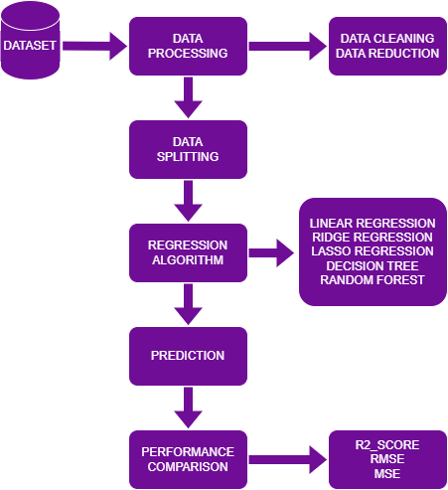

1. Dataset Flow Chart

## Correlation Matrix

The correlation matrix is used to see the correlation between the attributes. Highly correlated attributes and the target attribute are selected. It is the table to display the correlation coefficients between the attributes and variables of the dataset. It is useful for visualizing the relationships between the variables. The correlation matrix of all the relevant attributes of the dataset post data processing has been plotted in Fig-2.

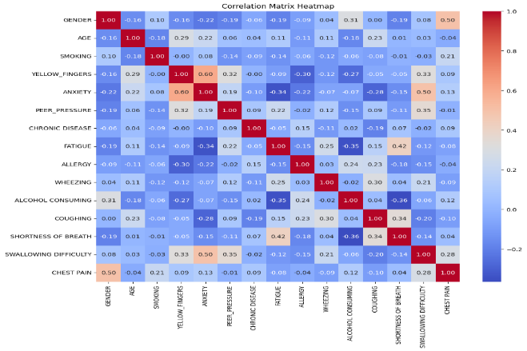

1. Correlation Matrix of all features after processing and cleaning the dataset

## Technology Models used

### Linear Regression Model

In order to determine a linear relationship between the input qualities and the target variable, this model is employed [16]. A model is created with the training dataset which is a hypothesis that takes the new input attribute and gives the output of the target attribute. Performance metrices are used to verify whether this model is performing well. A model is created using the training dataset, forming a hypothesis that predicts the target variable from input features. Performance metrics are employed to validate the model. In Linear Regression, the best-fit line is determined to model the relationship between input features (x-axis) and the target variable (y-axis), this has been shown in Eq-1.

|  |  |  |
| --- | --- | --- |
|  | $$y= β_{0}+β_{1}x_{1}+…+β_{n}x_{n}+ϵ$$ | (1) |

*β₀* is the Intercept. When *x = 0* then *y = β₀*. This shows that at what point the line is meeting the y axis. *β₁, β₂, …, βₙ* are the slope or coefficients for the input features *x₁, x₂, …, xₙ*

*ϵ* denotes the error term that the unnecessary noise in the relationship between attributes. Although it is always believed that the dependent and independent qualities have a linear connection, algorithms work best when the independent and dependent variables do. Linear Regression is optimized for fast speeds.

### Ridge Regression

This is applied to prevent overfitting. It is used in such a way that the model should never overfit [17]. It introduces an L2 regularization term to the linear regression to ensure model stability, this has been shown in Eq-2.

|  |  |  |
| --- | --- | --- |
|  | $$\sum_{\left\{i=1\right\}}^{n}{{\left(y_{i}-{\hat{y}}_{i}\right)}^{2}+λ\sum_{\left\{j=1\right\}}^{m}{β_{j}^{2}}}$$ | (2) |

$λ$ (lambda) is the hyperparameter controlling the penalty strength and $β_{j}$ are the coefficients.

Coefficients are shrunken towards zero. On changing the values, a best fit line is obtained. After the line a slop is obtained which will decrease each time. After sometime this value will not decrease it will be a minimal and smaller value. Iterations are specified that is how many times the data is trained. Iteration is also a hyperparameter. Obtaining a 0 is not possible because then it will be an overfitting model. It is best to use for datasets where overfitting is a risk.

### Lasso Regression

This model adds the sum of mod slope instead of square of slope. This Mod of slop work is to do feature selection [18]. On summing the values, the slope value will be extremely small for the features that are not playing a significant role. The entire feature is then neglected. Eq-3 mathematically shows the formula of Lasso Regression.

|  |  |  |
| --- | --- | --- |
|  |  | (3) |

Ridge Regression does square of the slope which increases that particular value but because of the mod in Lasso Regression that value will not increase. In summary this neglects all features that are not at all important for this model. The major benefits of this model are to prevent overfitting and in cases where there are many features where many of them are not important. It performs feature selection. λ (lambda) is a hyperparameter which will be found out be cross validation. The cost function is to be reduced in such a way that it will never become zero but will be reduced based on the λ and the slope value.

### Decision Tree

This is a sort algorithm where data is split according to a certain parameter [19]. Feature are selected by Information gain. Decision Tree does not have a good time complexity for execution purpose. It splits all the features to its complete depth for training data, the accuracy is high and for test data the accuracy is low. It leads to low bias and high variance. This can be solved by pruning, but pruning is an extensive task for large datasets. Decision Tree Regression also uses Entropy, Information Gain, Gini Impurity to calculate the further results. Fig-3 shows the functioning of the Decision Tree regressor in detail with proper explanation of the root and leaf nodes.

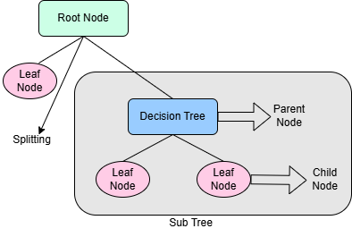

1. Decision Tree Regression

### Random Forest

The main problem with Decision Tree is that it leads to overfitting when it is created without a hyperparameter [20]. The main aim of Random Forest is to convert the high variance of decision tree to low variance. Random Forest is a bagging technique in which a dataset has multiple models. Each model is a Decision Tree that is going to be used in Random Forest. Each Decision Tree model creates Low bias and High Variance. Combining each Decision Tree model in the form of bootstrap aggregator the High Variance will be converted to low variance. This is because majority of the voting will be taken from these decision trees.

This is done by Majority Voting Classifiers. In Random Forest each model is created by Row Sampling and Feature Sampling. This means that some set of rows and some sets of features are given to each model. This leads to features getting repeated, records and datapoints also get repeated in the models. Each model will be an expert in predicting the specific data on which it was trained. Fig-4 shows the functioning of the Random Forest Regressor in detail with proper explanation taking different decision tree models.

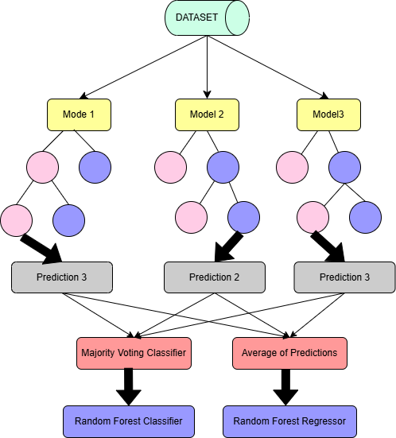

1. Random Forest Classifier

## Evaluation Matrix

Analyzing and testing datasets is the foundation of machine learning. provides the forecasts once the model has been processed using specific algorithms. The regression model's accuracy, or how well it anticipated the outcomes, is computed. There is a comparison between the predicted results and the actual values to test on how accurate the model behaves. Error represents any false predictions made by the model. The evaluation metrics that are used are –

### $R^{2}$ Score

R square is the coefficient of determination, varying from 0 to 1. It is represented by a percentage. Higher value of R square represents higher accuracy of the prediction model. Eq-6 shows the derivation of R-Square.

|  |  |  |
| --- | --- | --- |
|  | $$R^{2}=1-\frac{∑{\left(x_{i}-{\hat{x}}_{l}\right)}^{2}}{∑{\left(x_{i}-`x_{l}\right)}^{2}}$$ | (6) |

$`x_{l}$ states the mean value of x

### Mean Squared Error (MSE)

The average of the squared errors is known as the Mean Squared Error, or MSE. It represents the difference between the mean squared of the predicted and the actual values. Eq-4 shows the derivation of MSE.

|  |  |  |
| --- | --- | --- |
|  | $$MSE=\frac{1}{k}\sum_{i=1}^{k}{{\left(x_{i}-{\hat{x}}_{1}\right)}^{2}}$$ | (4) |

$k$ in Eq-4 shows the number of predictions,

*x* represents the actual values

$\hat{x}$ are the values predicted by the model

### Root Mean Square Error (RMSE)

The square root of the mean of the squared errors is known as the root mean square error. It is the Mean Square Error squared. The error is the discrepancy between the expected and actual value. Eq-5 shows the derivation of RMSE.

|  |  |  |
| --- | --- | --- |
|  | $$RMSE=\sqrt{MSE}=\sqrt{\frac{1}{k}\sum_{i=1}^{k}{{\left(x_{i}-{\hat{x}}_{1}\right)}^{2}}}$$ | (5) |

# Results And Discussion

Various machine learning regression models were evaluated on the dataset based on their performance to observe the best accuracy and effectiveness of a model. The performance of a regressor model can be evaluated by checking the Mean Squared Error (MSE), the coefficient of determination (R2_Score) and the Root Mean Squared Error (RMSE). The Random Forest Regression outperforms other regression model by giving the best results in R2 Score. Table 2 shows the performance of the various regression models used in the study concerning the evaluating metrics. It shows the R2 Score, MSE and RMSE values of all the regression models.

Table II. Analysis of related work

|  |  |  |  |
| --- | --- | --- | --- |
| Models | R2 Score | MSE | RMSE |
| Ridge Regression | -0.4755 | 0.0461 | 0.2146 |
| Linear Regression | -0.6804 | 0.0525 | 0.2290 |
| Lasso Regression | -0.6330 | 0.0510 | 0.2258 |
| Decision Tree Regressor | -0.0333 | 0.0323 | 0.1796 |
| Random Forest Regressor | 0.2447 | 0.0228 | 0.1536 |

By comparing the various machine learning regression models applied from Table 2 for predicting lung cancer it has been found that the higher the score of the coefficient of determination (R-squared) lower is the Mean Squared Error (MSE) and the Root Mean Squared Error (RMSE). These value and interpretation help to predict which model performs best according to the given dataset giving the best possible results accurately. It has been found out that Random Forest Regression outperforms other regression models with a 0.2447 R-Square score, MSE score of 0.0228 and 0.1536 RMSE score. Fig. 5 (a) and 5 (b) shows the graphical representation of R2 and RMSE.

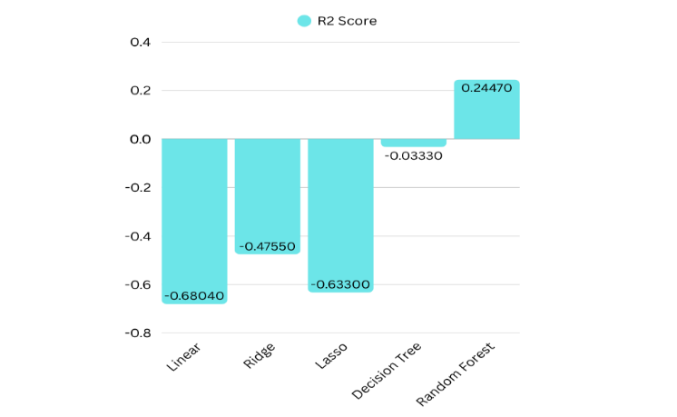

(a)

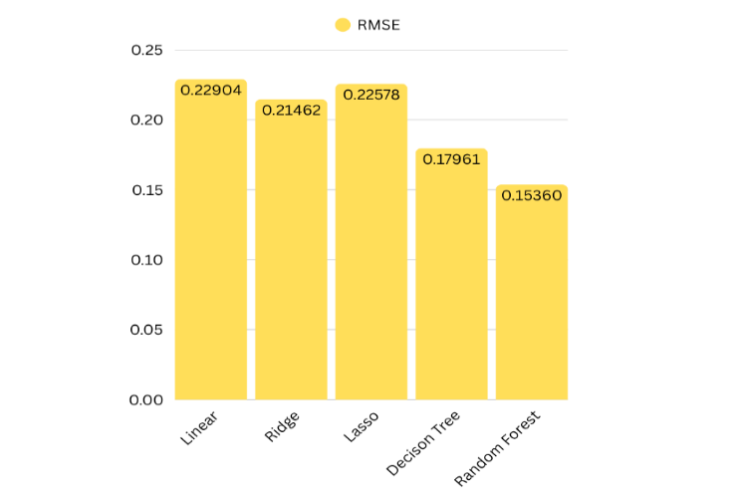

(b)

1. Measure of Performance of various algorithms for (a) R_2 Score (b) RMSE.

Fig. 6 depicts the performance of various algorithms graphically in terms of MSE. The least performing regression model was found to be Linear Regression with a -0.6804 R-Square score, 0.0525 MSE score and a 0.2290 RMSE score.

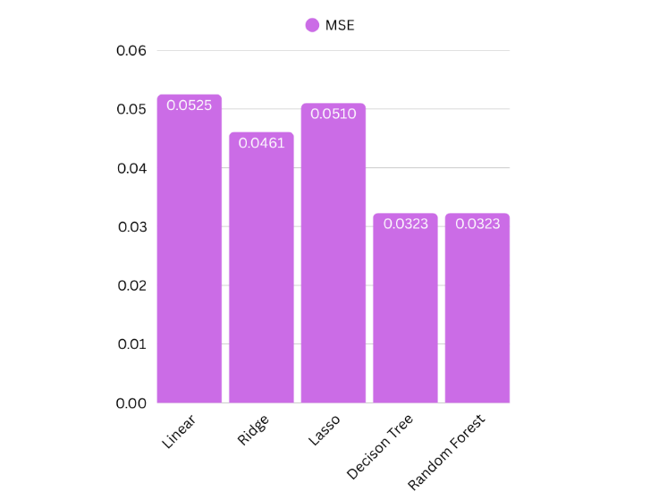

1. Measure of Performance of various algorithms for MSE.

Age comes as the feature of most importance in the Random Forest training model. Fig. 7 graphically depicts all the features and attributes of the dataset with their importance in the random forest training model.

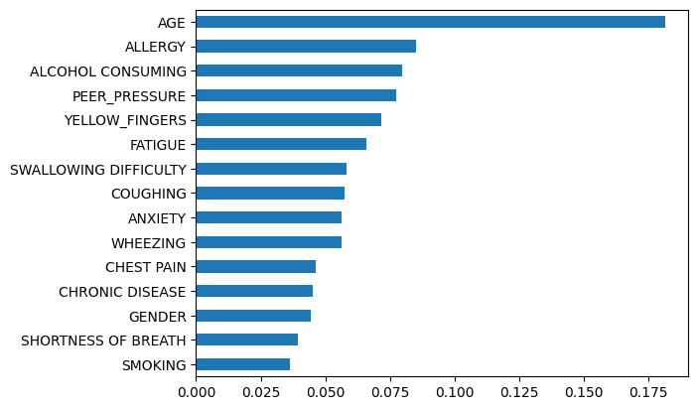

1. Importance of Attributes of the Dataset

# Conclusion And Future Work

This paper uses the basic life habits and information about the person to predict lung cancer. Many evaluation techniques like Root Mean Square Error are used on different machine learning models. Regression Models used to predict cancer are Linear Regression, Ridge Regression and Lasso Regression. Classifier Models like Decision Trees Classifier, Logistic Regression, and Random Forests were proved to have more accuracy in predicting lung cancer. This helps the patients and doctors to detect lung cancer easily just by their habits and basic information. This paper shows that Random Forest Regression model performs best among as compared to other models. It outperforms as the best regression model giving the best R2 Score, MSE and RMSE when trained and tested on the given dataset of lung cancer derived from the symptoms several patients.

For further research, the researchers can develop a mobile application to take the information and habits of the user on a daily basis and warn them if they are at a risk of lung cancer. This can be done by machine learning algorithms for predicting cancer more accurately.

##### REFERENCES

1. World Health Organization (WHO) Report about Lung Cancer, [Who Report About Lung Cancer](https://www.who.int/news-room/fact-sheets/detail/lung-cancer), 2023. <https://www.who.int/news-room/fact-sheets/detail/lung-cancer>
2. World Cancer Research Fund report about Lung Cancer 2022. <https://www.wcrf.org/preventing-cancer/cancer-statistics/lung-cancer-statistics/>
3. S. S. Raoof, M. A. Jabbar and S. A. Fathima. "Lung Cancer prediction using machine learning: A comprehensive approach." In *2020 2nd International conference on innovative mechanisms for industry applications (ICIMIA)*, pp. 108-115. IEEE, 2020
4. A.Worawate, A. Thirach, S. Marukatat, and T. Wilaiprasitporn. "Automatic lung cancer prediction from chest X-ray images using the deep learning approach." In *2018 11th biomedical engineering international conference (BMEiCON)*, pp. 1-5. IEEE, 2018.
5. T. Choudhury, D. Ghosh, M.K. Gourisaria, J.J. Jena, P. Pattnayak, A. Bandyopadhyay. "Revolutionizing H5_HPAI Detection: Role of Machine Learning in Early Diagnosis." In 2024 Second International Conference on Intelligent Cyber Physical Systems and Internet of Things (ICoICI), pp. 882-887. IEEE, 2024.
6. S.K. Bharti, D. Ghosh, M. K. Gourisaria, J. J. Jena, P. Pattnayak, S.S. Patra. "Beyond the Biopsy: A Comprehensive Machine Learning Based Approach to Thyroid Cancer Staging." In 2024 Second International Conference on Intelligent Cyber Physical Systems and Internet of Things (ICoICI), pp. 846-851. IEEE, 2024.
7. Y. Singh, D. Ghosh, M.K. Gourisaria, J.J. Jena, S.S. Patra, A.R. Panda. "Machine Learning Empowered Osteoporosis Prediction: A Comparative Analysis." In 2024 5th International Conference on Electronics and Sustainable Communication Systems (ICESC), pp. 962-967. IEEE, 2024.
8. C. Thallam, A. Peruboyina, S. S. T. Raju and N. Sampath. "Early stage lung cancer prediction using various machine learning techniques." In *2020 4th International Conference on Electronics, Communication and Aerospace Technology (ICECA)*, pp. 1285-1292. IEEE, 2020.
9. F. M. Imran, Saba Bashir, Zain Sikandar Khan, and Farhan Hassan Khan. "An evaluation of machine learning classifiers and ensembles for early stage prediction of lung cancer." In *2018 3rd international conference on emerging trends in engineering, sciences and technology (ICEEST)*, pp. 1-4. IEEE, 2018.
10. E. Dritsas and M. Trigka, Lung cancer risk prediction with machine learning models. *Big Data and Cognitive Computing*, *6*(4), p.139, 2022
11. M. Mamun, A. Farjana, M. Al Mamun and M. S. Ahammed, "Lung cancer prediction model using ensemble learning techniques and a systematic review analysis." In *2022 IEEE World AI IoT Congress (AIIoT)*, pp. 187-193. IEEE, 2022.
12. K. Sivanagireddy, S. Yerram, S. S. N. Kowsalya, S. S. Sivasankari, J. Surendiran and R. G. Vidhya, "Early lung cancer prediction using correlation and regression." In *2022 International Conference on Computer, Power and Communications (ICCPC)*, pp. 24-28. IEEE, 2022.
13. B. Mamatha, D. Rashmi, S. K. Tiwari, A. P. Sikrant, A. Arokiaraj Jovith, and P. C. S. Reddy. "Lung Cancer Prediction from CT Images and using Deep Learning Techniques." In *2023 Second International Conference on Trends in Electrical, Electronics, and Computer Engineering (TEECCON)*, pp. 263-267. IEEE, 2023.
14. J. Surendiran, K. D. Kumar, T. Sathiya, S. S. Sivasankari, R. G. Vidhya, and N. Balaji. "Prediction of lung cancer at early stage using correlation analysis and regression modelling." In *2022 Fourth International Conference on Cognitive Computing and Information Processing (CCIP)*, pp. 1-6. IEEE, 2022.
15. A. Khairnar**, “**Lung Cancer Dataset” Kaggle – Does Smoking cause Lung Cancer (Version 1) 2021, Retrieved on 24th March 2025, <https://www.kaggle.com/code/khairnaratharva/addbost-98-387-knn-96-7741-lr-svm-dt-rf>
16. J. Gareth, D. Witten, T. Hastie, R. Tibshirani, and J. Taylor. "Linear regression." In  “An introduction to statistical learning: With applications in python”, pp. 69-134. Cham: Springer international publishing, 2023.
17. G.C. McDonald, Ridge regression. *Wiley Interdisciplinary Reviews: Computational Statistics*, *1*(1), pp.93-100, 2009
18. J. Ranstam, & J. A. Cook, LASSO regression. Journal of British Surgery, 105(10), 1348-1348, 2018.
19. D. B. Ville, Decision trees. Wiley Interdisciplinary Reviews: Computational Statistics, 5(6), 448-455, 2013.
20. S. J. Rigatti. Random forest. Journal of Insurance Medicine, 47(1), 31-39, 2017.